Gastvortrag Digital Humanities
Professor Ryan Cordell, Ph.D.
Northeastern University, Boston, MA

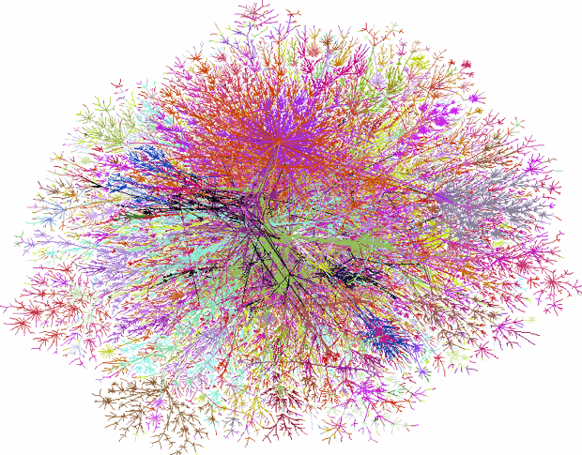
“Scale as Deformance:
The Particulars of ‘Big Data’ in Humanities Research”

Donnerstag, 21.4.2016, 14:00-15:30 Uhr, Raum 17.72

